 |  | Name | Duration | Start | Finish | Predecessors
1 |  | Decision on Problem Dom... | 5 days | 5/2/18 9:00 AM | 12/2/18 9:00 AM
2 |  | Definition of Problem Statement | 3 days? | 5/2/18 9:00 AM | 8/2/18 9:00 AM
3 |  | Languages and tools | 2 days? | 8/2/18 9:00 AM | 12/2/18 9:00 AM
4 |  | Survey and Dataset | 6 days? | 12/2/18 8:00 AM | 19/2/18 5:00 PM
5 |  | Research on Dataset | 3 days? | 12/2/18 8:00 AM | 14/2/18 5:00 PM
6 |  | Synopsis | 1 day? | 15/2/18 8:00 AM | 15/2/18 5:00 PM
7 |  | Literature Survey | 2 days? | 16/2/18 8:00 AM | 19/2/18 5:00 PM
8 |  | Data Preprocessing | 9 days? | 20/2/18 8:00 AM | 2/3/18 5:00 PM
9 |  | Data description reading | 2 days? | 20/2/18 8:00 AM | 21/2/18 5:00 PM
10 |  | System Design | 2 days? | 22/2/18 8:00 AM | 23/2/18 5:00 PM
11 |  | Feature Scaling and Normaliz... | 5 days? | 24/2/18 8:00 AM | 2/3/18 5:00 PM
12 |  | Data Analysis | 21 days? | 5/3/18 8:00 AM | 2/4/18 5:00 PM
13 |  | Statistical Analysis on features | 5 days? | 5/3/18 8:00 AM | 9/3/18 5:00 PM
14 |  | Implementation of Time Serie... | 6 days? | 10/3/18 8:00 AM | 19/3/18 5:00 PM
15 |  | Interpretation and Prediction | 5 days? | 20/3/18 8:00 AM | 26/3/18 5:00 PM
16 |  | Optimization | 5 days | 27/3/18 8:00 AM | 2/4/18 5:00 PM
17 |  | Final Testing | 5 days? | 3/4/18 8:00 AM | 9/4/18 5:00 PM
18 |  | Testing of Project | 5 days? | 3/4/18 8:00 AM | 9/4/18 5:00 PM
19 |  | Documentation | 5 days | 10/4/18 8:00 AM | 16/4/18 5:00 PM
20 |  | Writing of the report | 5 days | 10/4/18 8:00 AM | 16/4/18 5:00 PM
21 |  | Paper Submission | 5 days | 17/4/18 8:00 AM | 23/4/18 5:00 PM
22 |  | Working on writing of the paper | 5 days | 17/4/18 8:00 AM | 23/4/18 5:00 PM

Accident - page1
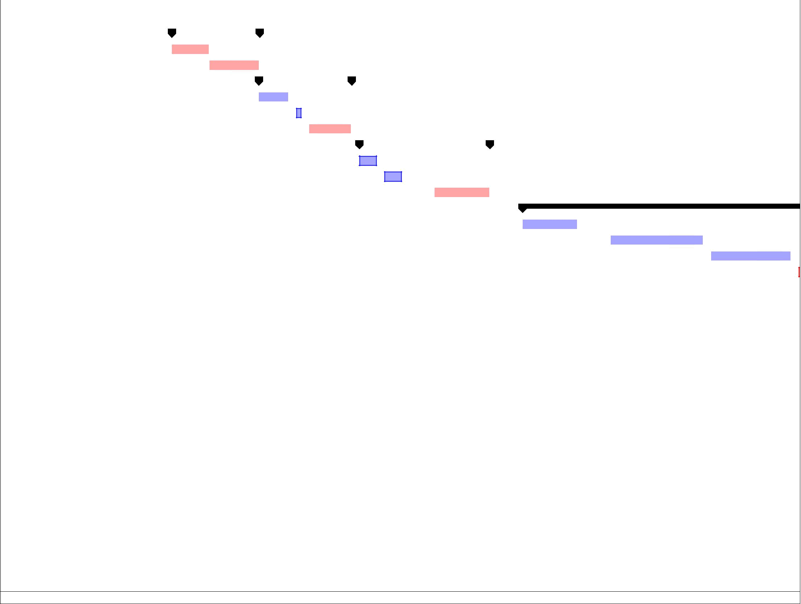  Resource Names |  |  | 4 Feb 18 |  |  |  |  |  |  |  |  | 11 Feb 18 |  |  |  |  |  |  |  |  |  | 18 Feb 18 |  |  |  |  |  |  |  | 25 Feb 18 |  |  |  |  |  |  |  |  | 4 Mar 18 |  |  |  |  |  |  |  |  | 11 Mar 18 |  |  |  |  |  |  |  | 18 Mar 18 |  |  |  |  |  |  |  |  | 25 Mar
 | F | S | S | M |  | T | W | T |  | F | S | S | M |  | T | W |  | T | F |  | S | S | M |  | T | W | T | F | S | S | M |  | T | W | T | F |  | S | S | M |  | T | W | T | F |  | S | S | M |  | T | W | T | F | S | S | M |  | T |  | W | T | F | S | S | M |  | T

Accident - page2

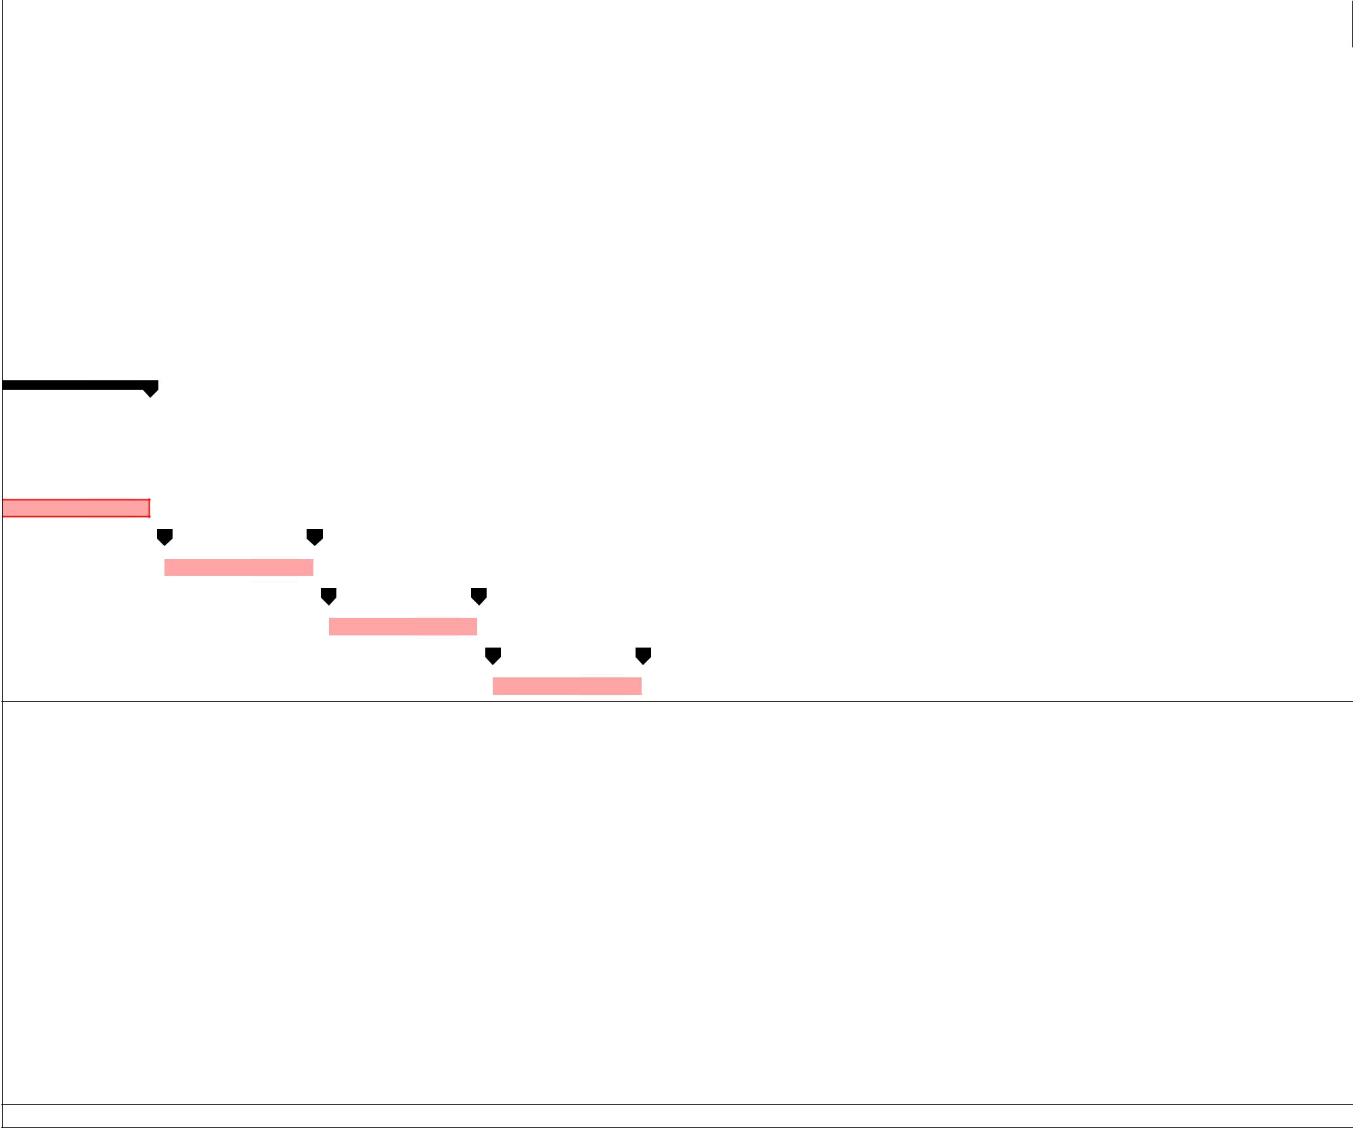 | 18 |  |  |  |  | 1 Apr 18 |  |  |  |  |  |  |  | 8 Apr 18 |  |  |  |  |  |  |  |  | 15 Apr 18 |  |  |  |  |  |  |  |  | 22 Apr 18 |  |  |  |  |  |  |  | 29 Apr 18 |  |  |  |  |  |  | 6 May 18 |  |  |  |  |  |  | 13 May 18 |  |  |  |  |  |  | 20 May 18
T |  | W | T | F | S | S | M | T |  | W | T | F | S | S | M |  | T |  | W | T | F | S | S | M |  | T |  | W | T | F | S | S | M |  | T | W | T | F | S | S | M | T | W | T | F | S | S | M | T | W | T | F | S | S | M | T | W | T | F | S | S | M | T | W

Accident - page3

